P1: Test a Perceptual Phenomenon

1. The Independent variable is the Words Displayed (Congruent & Incongruent). The Dependent variable is the reaction time of the participants.
2. For this experiment, I would set the Null Hypothesis to be that the two populations and population means are the same for the congruent & incongruent sets.

**H0: µC = µI**

The Alternative Hypothesis however is that there IS a difference between the two populations and population means.

**H1: µC != µI**

**H1: µC < µI**

**H1**: **µC > µI**

The Statistical Test I expect to perform will be a Paired T-Test. I am choosing a T-Test because I will be comparing the means of two groups (unlike 3 or more which would require an ANOVA test). Also, because my dependent variable is numeric, it would make more sense for the test to be a T Test, as opposed to a Chi Squared Test which is what would be more appropriate if my dependent variable was categorical. Lastly, I am choosing for my T- Test to be paired as opposed to unpaired because the participants are the same for both conditions.

1. Congruent Set:

Mean = 14.05 / Median = 14.3565 / Mode = No Mode / Range = 13.698 / Variance = 12.669 / Standard Deviation = 3.559

Incongruent Set:

Mean = 22.0159 / Median = 21.0175 / Mode = No Mode / Range = 19.568 / Variance = 23.0118 / Standard Deviation = 4.7971

1. The Incongruent set has a larger median of completion time than the Congruent set (as well as a higher IQR). The Incongruent set’s maximum value is also its Q3 (upper quartile). The Congruent set has a tall upper whisker separating its upper quartile from its upper extreme.

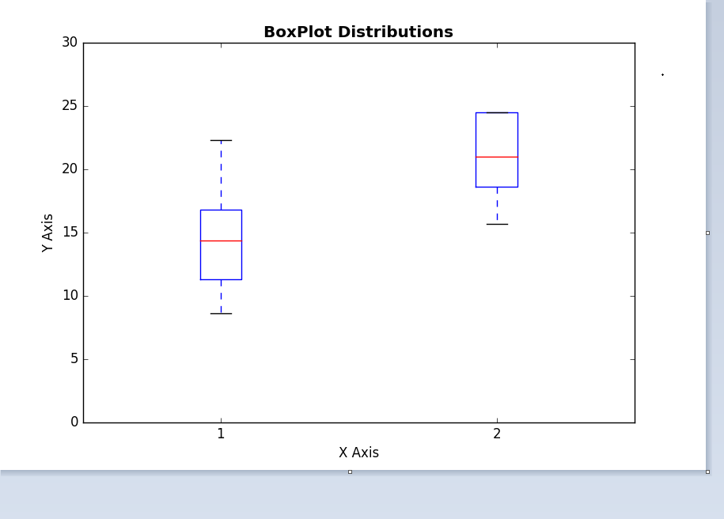

[Code Below for Plot Above]

*import numpy as np*

*import pandas as pd*

*import matplotlib.pyplot as plt*

*median1 = 14.36*

*q1_1 = 11.34*

*q3_1 = 16.79*

*min1 = 8.63*

*max1 = 22.33*

*cong = np.array([median1, q1_1, q3_1, min1, max1])*

*median2 = 21.02*

*q1_2 = 18.64*

*q3_2 = 24.52*

*min2 = 15.69*

*max2 = 35.26*

*incong = np.array([median2, q1_2, q3_2, min2, max2])*

*fig_2_plot = [cong, incong]*

*fig = plt.figure(1, figsize =(9, 6))*

*ax = fig.add_subplot(111)*

*ax.set_title('BoxPlot Distributions', fontweight = 'bold')*

*ax.set_xlabel('X Axis')*

*ax.set_ylabel('Y Axis')*

*ax.set_ylim(0, 30)*

*bp = ax.boxplot(fig_2_plot)*

*plt.show()*

1. My 95% Confidence Interval of Mean Difference:

5.91056 – 10.01903

The Mean of Group 1 minus the Mean of Group 2 = 7.96479

7.96 +- 2.069 Critical Value = 95% CI Listed Above

df = 23 / t = 8.0207 / SE of Diff = 0.993

My 2-Tailed P-Value is less than .0001, thus making it Extremely Statistically Significant.

Consequently, the probability of getting a score in the 95% CI level is less than .0001, which means our test statistic falls within the rejection region. As a result, we in turn REJECT THE NULL.

The results did in fact match up with my expectations (**HA: Hc < Hi** ) despite it being conflicting to the Null. In my mind, it makes perfect sense for the reaction time to be shorter for words whose meaning match their true colors than for words whose do not.